

CP3407- Introductory Machine Learning and Data Science

Group 4
Li Zhipeng
Jiang Zhonghao
Zhang Yiwen
Lecturer name: Dasheng Liu
Date: 8/4/2025

Contact
Workshop1: 2
Workshop2： 3
Target Users 4
Functional Requirements 4
Feature Development Time Estimation 6
Total Development Time Estimation 6
Workshop3 7
Activity One: Prioritization and Iteration Planning 7
Activity Two: Implementing One User Story 7
Workshop 4 9
Activity One 9
1. Information Support 9
2. Interactive Activity Suggestions 10
3. Data Privacy and Multilingual Support 11
4. Feedback Collection 12
Summary of Estimated Times for Each User Story: 13
Activity Two 13
Sequence of Interactions: 14
Explanation of Diagram Steps: 15
Workshop5 16
Project Progress 17
Current Issues & Challenges 18
Workshop6 19
Conflict recording and resolution 20
Workshop7 21
User Story 1: Answer orientation event questions (Leo) 21
User Story 2: Provide academic resource information (William) 21
User Story 3: Recommend team - building activities (Sky) 22
User Story 4: Recommend activities based on interests (River) 22
User Story 5: Provide multilingual support (William) 23
Workshop8 25
Activity One: Research on Strategy Pattern 25
Activity Two: Research on Mock Object Framework and Implementation in Project Testing 26
Workshop9 28
Activity One: System Testing Policy 28
Activity Two: System Testing Plan 29

Workshop1:
Group 4

Github link: https://github.com/lzhpeng/CP3407

Website:
https://lzhpeng.github.io/CP3407-group4/
Group members:
Li Zhipeng
Jiang zhonghao
Zhang yiwen

Workshop2：

Target Users
Leo (Domestic student, Liberal Arts major)
Needs: Lily needs quick access to information about orientation events, academic resources, and interactive activity recommendations to help integrate into campus life.
William (International student, Science major)
Needs: Zachary needs multilingual support (Chinese and English), data privacy protection, and detailed information about academic resources and orientation activities.
River (Domestic student, Arts major)
Needs: Wendy is interested in creative and artsy interactive activities, and needs recommendations that can help her connect with others who share similar interests.
Sky (Domestic student, Business major)
Needs: Leo wants to know about team-building activities and orientation events, and would like personalized suggestions to improve his teamwork skills and integrate better into the campus.

Functional Requirements

1. Information Support
- Description: The chatbot should respond to students' questions about the orientation schedule, events, academic resources, and other essential information.
- User Stories:
Title: Answer orientation event questions
As: Leo
I want: The chatbot to provide information about orientation events
So that: Students can quickly find out the event schedule and details
Estimation: 8 days
Title: Provide academic resource information
As: William
I want: The chatbot to provide information about academic resources and course schedules
So that: Students can access the academic information I need
Estimation: 4 days

2. Interactive Activity Suggestions
- Description: The chatbot should recommend activities based on student interests to promote socialization and campus integration.
- User Stories:
Title: Recommend team-building activities
As: Sky
I want: The chatbot to suggest team-building games and activities
So that: Students can connect with others and work effectively in groups
Estimation: 3 days
Title: Recommend activities based on interests
As: River
I want: The chatbot to recommend activities related to my interests (arts)
So that: Students can connect with other like-minded students
Estimation: 3 days

3. Data Privacy and Multilingual Support
- Description: The chatbot must protect student data and provide multilingual support to accommodate international students.
- User Stories:
Title: Provide multilingual support
As: William
I want: The chatbot to support Multilingual
So that: Students can understand the information provided in my native language
Estimation: 5 days

4. Feedback Collection
- Description: The chatbot should collect feedback on its performance and use it to improve future versions and the orientation program.
- User Stories:
Title: Collect user feedback
As: Leo
I want: To provide feedback on the chatbot's performance
So that: The chatbot can improve and provide a better experience in future
Estimation: 10days

Feature Development Time Estimation
- Information Support Feature: 12 days
- Interactive Activity Recommendation Feature: 6 days
- Data Privacy and Multilingual Support: 8 days
- Feedback Collection Feature: 10 days

Total Development Time Estimation
- Total Development Time: 36 days

Workshop3

Activity One: Prioritization and Iteration Planning

Iteration 1 (Weeks 1-2) - Core Functionalities
- Answer orientation event questions (8 days)
- Provide academic resource information (4 days)

Iteration 2 (Weeks 3-4) - Enhancing Engagement
- Recommend team-building activities (3 days)
- Recommend activities based on interests (3 days)
- Provide multilingual support (5 days)

Iteration 3 (Weeks 5-7) - Continuous Improvement
- Collect user feedback (10 days)

Activity Two: Implementing One User Story
To start, let's implement "Answer orientation event questions" since it's crucial for helping students navigate orientation.
Orientation events play a key role in helping students transition into campus life. It's essential that the chatbot efficiently responds to student queries about the orientation schedule, event details, locations, and timeframes. By answering orientation event questions, the chatbot will serve as a go-to resource, offering students quick and easy access to event schedules, allowing them to plan and integrate into campus life effectively.
"schedule": "The orientation schedule includes a welcome speech at 9 AM, campus tour at 11 AM, and networking lunch at 1 PM.",
"location": "The orientation events will take place in the JCU, Room A208.",
"activities": "Orientation includes interactive sessions, ice-breaking games, and faculty introductions，More can be asked of volunteers。",
"contact": "You can contact the Student Affairs Office at (123) 456-7890 for more information."

Workshop 4
Activity One
Break your user stories into tasks and provide estimation for each task.

1. Information Support
Description: The chatbot should respond to students' questions about the orientation schedule, events, academic resources, and other essential information.

User Story 1: Answer orientation event questions (Leo)
- Estimation: 8 days

Tasks:
Data collection for orientation events
  - Estimation: 2 days
Create event database/JSON file
  - Estimation: 2 days
Develop querying mechanism for chatbot
  - Estimation: 2 days
Design NLP matching system
  - Estimation: 1 day
Integrate chatbot with event database
  - Estimation: 1 day
Test and debug
  - Estimation: 2 days
Documentation and deployment
  - Estimation: 1 day

User Story 2: Provide academic resource information (William)
- Estimation: 4 days

Tasks:
Gather academic resource details (library, tutoring, course schedules, etc.)
  - Estimation: 1 day
Create academic resources database/JSON file
  - Estimation: 1 day
Develop querying mechanism for academic resources
  - Estimation: 1 day
Design NLP matching system for academic queries
  - Estimation: 1 day
Integrate chatbot with academic resources data
  - Estimation: 1 day
Test and debug
  - Estimation: 1 day

2. Interactive Activity Suggestions
Description: The chatbot should recommend activities based on student interests to promote socialization and campus integration.

User Story 3: Recommend team-building activities (Sky)
- Estimation: 3 days

Tasks:
Research team-building activities
  - Estimation: 1 day
Create a list of suggested activities
  - Estimation: 1 day
Develop querying mechanism for team-building activities
  - Estimation: 1 day
Test and debug
  - Estimation: 1 day

User Story 4: Recommend activities based on interests (River)
- Estimation: 3 days

Tasks:
Research and gather activity options for arts-related interests
  - Estimation: 1 day
Create a list of arts-related activities
  - Estimation: 1 day
Develop querying mechanism for activity suggestions
  - Estimation: 1 day
Test and debug
  - Estimation: 1 day

3. Data Privacy and Multilingual Support
Description: The chatbot must protect student data and provide multilingual support to accommodate international students.

User Story 5: Provide multilingual support (William)
Estimation: 5 days

Tasks:
Research multilingual support options for chatbot
  - Estimation: 1 day
Develop multilingual language selection feature
  - Estimation: 2 days
Integrate language options for responses (Chinese, English)
  - Estimation: 2 days
Test and debug multilingual feature
  - Estimation: 1 day

4. Feedback Collection
Description: The chatbot should collect feedback on its performance and use it to improve future versions and the orientation program.

User Story 6: Collect user feedback (Leo)
- Estimation: 10 days

Tasks:
Design feedback collection system
  - Estimation: 2 days
Develop feedback collection feature in chatbot
  - Estimation: 4 days
Test feedback collection system
  - Estimation: 2 days
Analyze feedback and improve chatbot performance
  - Estimation: 2 days
Documentation and deployment
  - Estimation: 1 day

Summary of Estimated Times for Each User Story:
- User Story 1: Answer orientation event questions – 8 days
- User Story 2: Provide academic resource information – 4 days
- User Story 3: Recommend team-building activities – 3 days
- User Story 4: Recommend activities based on interests – 3 days
- User Story 5: Provide multilingual support – 5 days
- User Story 6: Collect user feedback – 10 days
Activity Two
Develop class diagrams of your project.
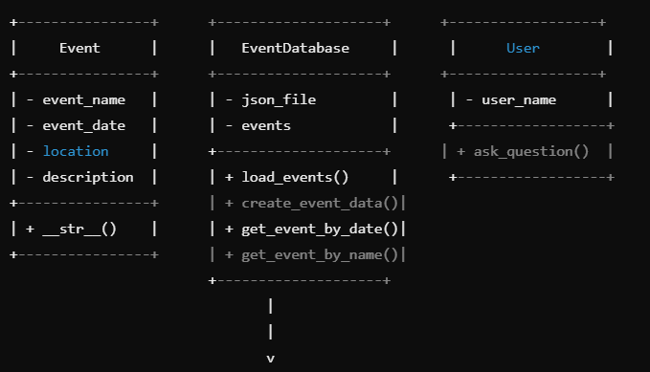
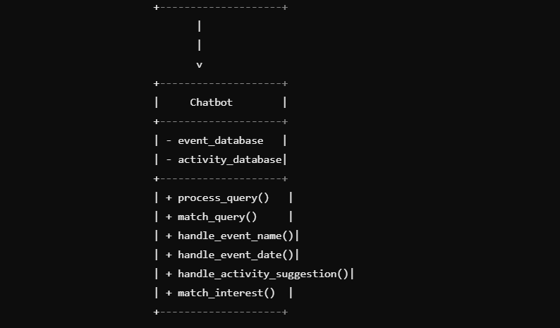

Explanation of Relationships:
This class diagram clearly shows the relationships between the main classes in your project: Event, EventDatabase, Chatbot, and User.

Activity Three
Develop at least one sequence diagram to illustrate the key features/operations of your project.

Sequence of Interactions:
User initiates a conversation with the Chatbot asking for orientation event details.
  - Action: "Ask about orientation events"
  - Message: "What are the upcoming orientation events?"
Chatbot receives the user's request and decides to query the Event Database for event details.
  - Action: "Query the event database"
  - Message: "Get event details"
Event Database returns the list of upcoming events that match the request.
  - Action: "Retrieve event details"
  - Message: "Return event details (e.g., name, date, location, description)"
Chatbot formats the event information and sends it back to the User.
  - Action: "Format and send response"
  - Message: "Here are the upcoming orientation events: Event 1, Event 2..."
User receives the information and interacts with the chatbot (e.g., asks more questions or thanks the chatbot).
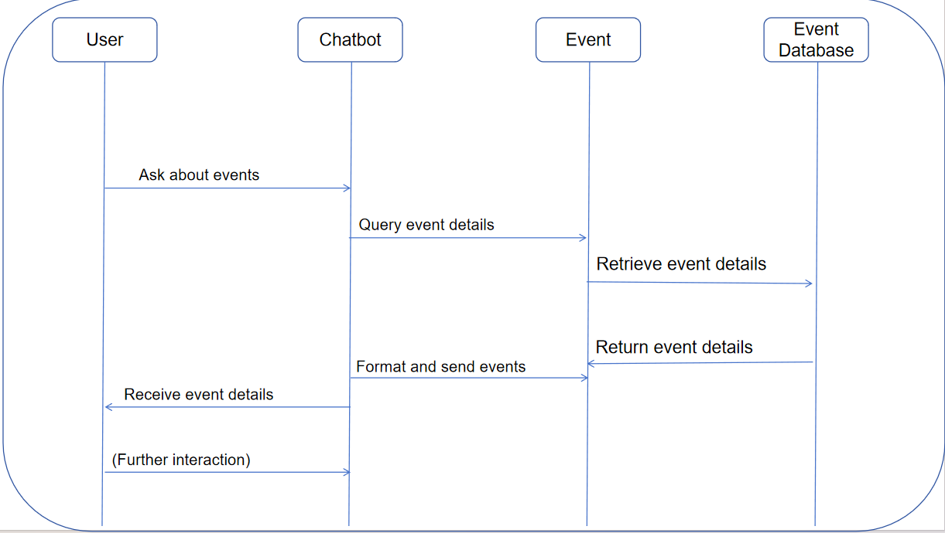

Explanation of Diagram Steps:
- User to Chatbot: The user initiates the interaction by asking the chatbot for orientation events.
- Chatbot to Event Database: The chatbot queries the Event Database for the event information.
- Event Database to Chatbot: The Event Database returns a list of events, such as their names, dates, and locations.
- Chatbot to User: The chatbot processes the event information and sends it to the user in a readable format.
- User: The user receives the event details and may ask further questions or provide feedback.

Workshop5

SRP:
Recommend team-building activities (Sky) & Recommend activities based on interests (River)

Provide multilingual support (William) & Provide academic resource information (William)

Collect user feedback (Leo)

DRY：

· Repeated event creation logic
load_events() and create_event_data() both contain event list creation logic. This should be extracted into a separate method.
· Repetitive string replacement in handle_event_date_query
"date" and "on" are removed separately. We can optimize this.
· Duplicate message handling in chatbot responses
handle_event_name_query and handle_event_date_query both handle "not found" cases separately. We can use a common method.
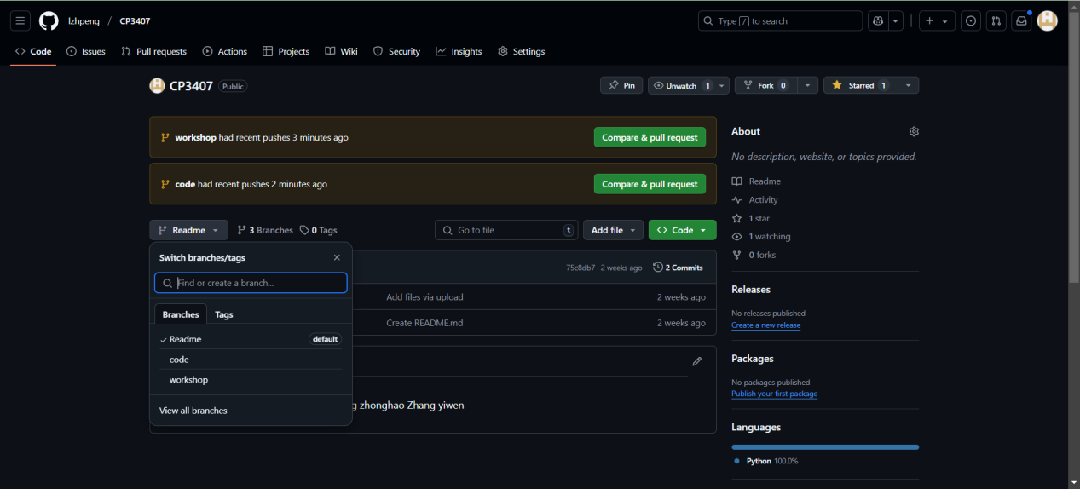

Project Progress
Over the past few workshops, I have been developing an Orientation Chatbot Application aimed at enhancing new students' engagement during their orientation program. The chatbot is designed to provide essential information, suggest interactive activities, support multiple languages, and collect feedback for continuous improvement.

Workshop 1-3: Planning and Feature Breakdown
I worked with my team to define target users, their needs, and key functional requirements. We structured our development plan by prioritizing essential features first and breaking them down into detailed user stories and tasks.
Core Features Identified
  - Information Support: Answer orientation event questions and provide academic resources.
  - Interactive Activity Suggestions: Recommend activities based on student interests.
  - Data Privacy & Multilingual Support: Ensure security and support different languages.
  - Feedback Collection: Gather user feedback to improve chatbot performance.
Development Timeline & Iterations
  - Iteration 1 (Weeks 1-2): Answer event-related questions and provide academic resources.
  - Iteration 2 (Weeks 3-4): Enhance engagement through activity suggestions and multilingual support.
  - Iteration 3 (Weeks 5-7): Implement feedback collection.

Workshop 4: Breaking Down Tasks & Designing Architecture
At this stage, I broke down each user story into detailed tasks with estimated timeframes. I also designed class diagrams to illustrate the system structure and sequence diagrams to visualize interactions. Key progress included:
- Data Storage: Created an event database (JSON format) to store orientation event details.
- Chatbot Querying System: Designed the chatbot’s NLP-based mechanism to match user queries with stored event data.
- Multilingual Support: Planned a structured way to integrate multiple languages into the chatbot’s responses.
- Feedback Collection: Defined how the chatbot will collect and process student feedback.

Workshop 5: Code Optimization (SRP & DRY Principles)
To improve code efficiency, I identified areas for optimization:
- Single Responsibility Principle (SRP): Separated features logically, ensuring each module handles only one responsibility.
- Don’t Repeat Yourself (DRY): Reduced redundant code by extracting common functionalities into reusable methods.

Current Issues & Challenges
NLP Query Matching Accuracy
The chatbot needs to match user queries with event information effectively. I’m working on improving the NLP model to handle variations in phrasing.
Multilingual Integration Complexity
Supporting multiple languages requires proper handling of translations while maintaining conversational flow. I’m exploring different translation APIs for seamless integration.
Feedback Collection & Analysis
While collecting feedback is straightforward, analyzing it meaningfully to improve the chatbot remains a challenge. I’m considering sentiment analysis techniques for better insights.
Testing & Debugging
Ensuring that the chatbot responds accurately and handles edge cases properly requires extensive testing, which is time-consuming.

Finalize the chatbot’s query processing logic to improve event information retrieval.

Our chatbot is designed to provide information only about school activities. Since it cannot answer all user questions, it will not respond to inquiries beyond its scope. However, users can use the chatbot to access contact information for volunteers who can assist with any additional questions or concerns.

Workshop6
1) Li Zhipeng reconstructs Jiang zhonghao's code
Problem analysis of the original code: In the event query logic compiled by Jiang zhonghao, the analysis of user input is relatively simple and direct, and it is prone to matching errors when dealing with complex or fuzzy query statements. For example, when a user types "I want to know the specific time of a campus tour," the existing logic might not be able to accurately extract the event name "campus tour."
Reconstruction idea and implementation: Natural language processing (NLP) library spaCy is introduced to identify key information in user input more accurately with its powerful language parsing ability. First install the spaCy library and the corresponding language model (such as python -m spacy download en_core_web_sm), then import and use it in your code. Make changes in the match_query and handle_event_query methods of the Chatbot class. In the match_query method, spaCy analyzes user input, extracts key information such as nouns and verbs, and then determines the query type according to these information. In the handle_event_query method, the parsing results are used to extract the query keywords more accurately and improve the accuracy of the query.
2) Jiang zhonghao reconstructs Zhang yiwen's code
Problem analysis of the original code: In the user interaction interface code written by Zhang yiwen, the input prompt information is relatively simple, and there is no friendly prompt for user input errors. For example, when a user enters a misformatted date, a generic error message is returned without explicitly informing the user of the reason for the error.
Refactoring ideas and implementations: Improve input prompts to be more detailed and instructive. At the same time, more specific error prompts are provided for different types of input errors. Make changes in the ask_question method of the User class and the handle_event_query method of the Chatbot class. In the User class, add a prompt for the input format example; In the Chatbot class, specify the correct date format when the date format is incorrect.

3) Zhang yiwen reconstructs Li Zhipeng's code
Analysis of the original code problem: Li Zhipeng wrote the database data reading and storage code, there is no data backup processing, once the data file is damaged or lost, it may lead to data loss.
Reconstruction idea and implementation: Add the data backup function to create a backup file each time data is saved. Backup files can be named in timestamp mode to ensure uniqueness. Modify it in the save_events method of the EventDatabase class.

Conflict recording and resolution
When the code was merged, Jiang zhonghao and Zhang yiwen conflicted with the modification of the handle_event_query method of the Chatbot class. Jiang zhonghao added a user input error message, and Zhang yiwen added backup data logic, resulting in code overlap.

Workshop7

Activity 1

User Story 1: Answer orientation event questions (Leo)
- Test Case 1:
  - Input: "What time is the welcome speech?"
  - Expected Output: "The orientation schedule includes a welcome speech at 9 AM."
  - Explanation: Checks if the chatbot can correctly retrieve and provide the time of a specific orientation event.
- Test Case 2:
  - Input: "Where is the campus tour held?"
  - Expected Output: "The orientation events will take place in the JCU, Room A208."
  - Explanation: Verifies that the chatbot can provide the location information for an orientation event.
- Test Case 3:
  - Input: "What activities are included in the orientation?"
  - Expected Output: "Orientation includes interactive sessions, ice - breaking games, and faculty introductions，More can be asked of volunteers。"
  - Explanation: Ensures the chatbot can list the activities included in the orientation.

User Story 2: Provide academic resource information (William)
- Test Case 1:
  - Input: "What are the library opening hours?"
  - Expected Output: [Assuming the library hours are known, relevant information should be provided. If not, a message like "No information available for library opening hours yet."]
  - Explanation: Tests the chatbot's ability to provide academic resource information related to the library.
- Test Case 2:
  - Input: "Where can I find tutoring services?"
  - Expected Output: [Location or contact details for tutoring services if available, or a relevant message if not.]
  - Explanation: Checks if the chatbot can provide information about tutoring services.
- Test Case 3:
  - Input: "What is the schedule for Math 101 course?"
  - Expected Output: [Course schedule for Math 101 if available, or an appropriate response if not.]
  - Explanation: Verifies the chatbot's ability to provide course schedule information.

User Story 3: Recommend team - building activities (Sky)
- Test Case 1:
  - Input: "Recommend a team - building activity for a group of 10 people."
  - Expected Output: [A suitable team - building activity for 10 people from the list of recommended activities.]
  - Explanation: Checks if the chatbot can recommend a team - building activity based on the group size.
- Test Case 2:
  - Input: "I want a fun team - building activity."
  - Expected Output: [A fun - oriented team - building activity from the list.]
  - Explanation: Ensures the chatbot can recommend activities based on a general preference.
- Test Case 3:
  - Input: "Do you have any outdoor team - building activities?"
  - Expected Output: [Outdoor team - building activities if available, or a message indicating no such activities.]
  - Explanation: Verifies the chatbot's ability to filter team - building activities by location.

User Story 4: Recommend activities based on interests (River)
- Test Case 1:
  - Input: "Recommend an art - related activity."
  - Expected Output: [An art - related activity from the list of recommended activities.]
  - Explanation: Checks if the chatbot can recommend an activity based on an art - related interest.
- Test Case 2:
  - Input: "I like painting. What activities can I join?"
  - Expected Output: [Painting - related activities if available, or relevant suggestions.]
  - Explanation: Verifies the chatbot's ability to recommend activities based on a specific art - related interest.
- Test Case 3:
  - Input: "Are there any art exhibitions on campus?"
  - Expected Output: [Information about art exhibitions on campus if available, or a negative response.]
  - Explanation: Ensures the chatbot can provide information about art - related events.

User Story 5: Provide multilingual support (William)
- Test Case 1:
  - Input (in Chinese): "新生入学活动的时间是什么时候？"
  - Expected Output (in Chinese): ["迎新活动的时间表包括上午 9 点的欢迎演讲，上午 11 点的校园参观，下午 1 点的社交午餐。"]
  - Explanation: Checks if the chatbot can handle Chinese input and provide Chinese - language output for orientation event information.
- Test Case 2:
  - Input (in English): "Where can I find academic resources?"
  - Expected Output (in English): [Appropriate response in English about academic resources.]
  - Explanation: Verifies the chatbot's ability to handle English input and provide English - language output for academic resource inquiries.
- Test Case 3:
  - Input (in Chinese): "有哪些和艺术相关的活动？"
  - Expected Output (in Chinese): [相关的艺术活动信息，如果有的话。]
  - Explanation: Ensures the chatbot can handle Chinese input and provide Chinese - language output for activity - based interest inquiries.

Activity 2
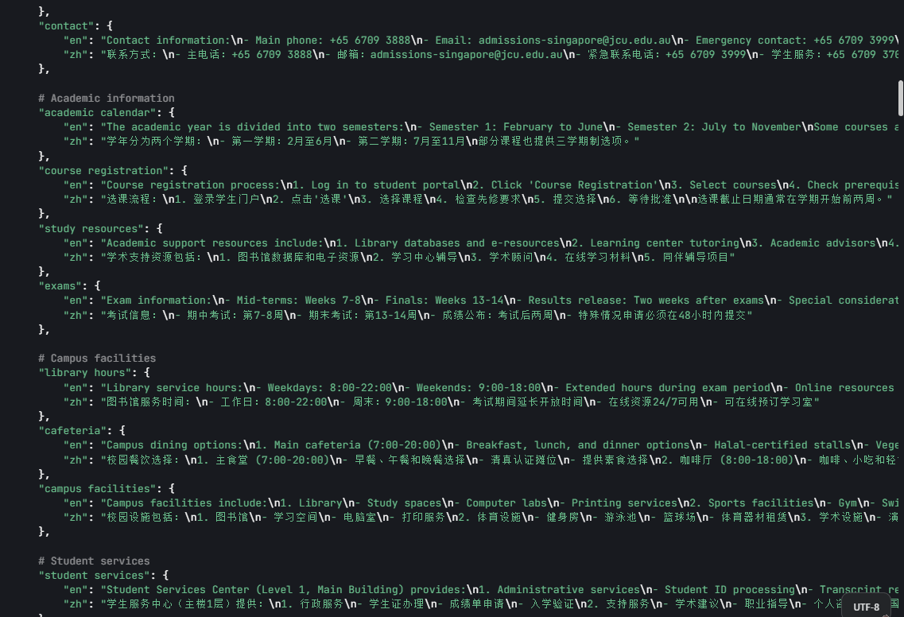

Workshop8

Activity One: Research on Strategy Pattern
1. Understanding the Strategy Pattern
The Strategy pattern is a behavioral design pattern that allows you to define a family of algorithms, encapsulate each one, and make them interchangeable. The pattern lets the algorithm vary independently from the clients that use it. In other words, it enables you to select an algorithm at runtime based on different conditions.

The main components of the Strategy pattern are:

- Strategy Interface: Defines a common interface for all concrete strategies.
- Concrete Strategies: Implement the strategy interface with different algorithms.
- Context: Holds a reference to a strategy object and uses it to perform a specific task.

2. Identifying the Strategy Pattern in the Project
In the provided app.py code, currently, there is no clear implementation of the Strategy pattern. However, we can identify a potential area where the Strategy pattern could be applied.

The Chatbot class has multiple text - processing methods such as analyze_sentiment, detect_language, etc. We can consider these as different algorithms for text processing. We can apply the Strategy pattern to make these algorithms more modular and interchangeable.

For example, we can create a TextProcessingStrategy interface and concrete strategies for sentiment analysis, language detection, etc. The Chatbot class can then use these strategies based on the type of processing required.

Here is a simple example of how the Strategy pattern could be applied to the sentiment analysis part:
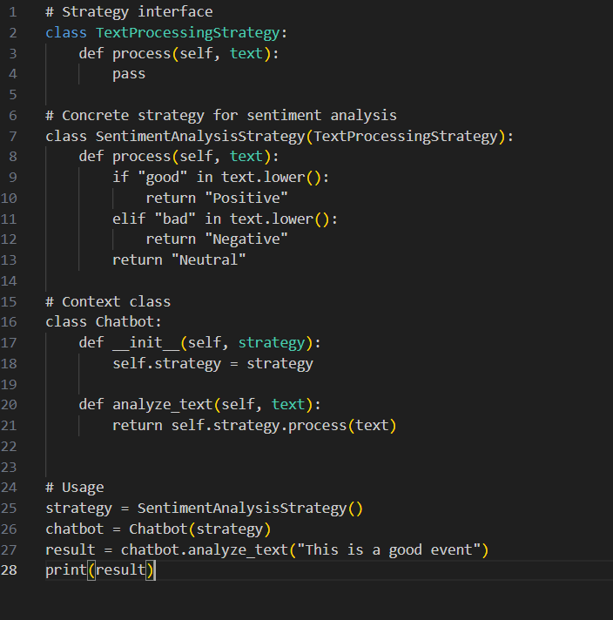

Activity Two: Research on Mock Object Framework and Implementation in Project Testing

1. Understanding Mock Object Framework
A mock object is a simulated object that mimics the behavior of a real object in a controlled way. Mock object frameworks are used in unit testing to isolate the unit of code being tested from its dependencies. They allow you to create objects that return predefined values, raise exceptions, or record interactions.

In Python, the unittest.mock library is a popular mock object framework. It provides a Mock class and a patch function to create and use mock objects.

2. Implementing Mock Objects in Project Testing
We will use the unittest.mock library to implement mock objects in the testing of the app.py project.

Here is an example of how to use mock objects to test the EventDatabase class:
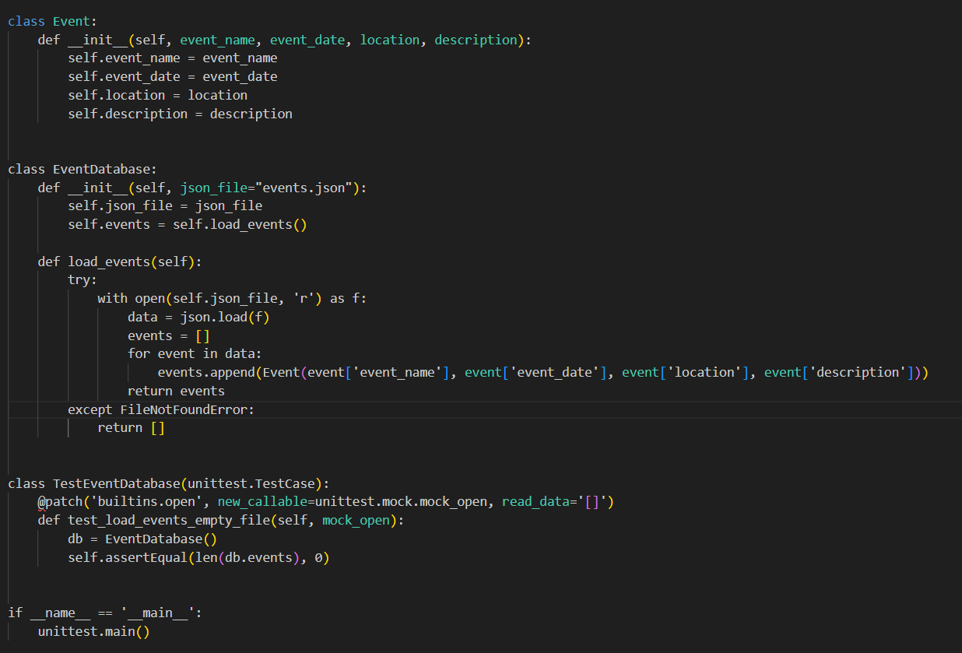
In this example, we use the patch function to replace the open function with a mock object. The mock_open function creates a mock file object that returns an empty list when read. This way, we can test the load_events method without actually reading a real file.

In conclusion, we have successfully researched the Strategy pattern and identified a potential area for its implementation in the project. We have also learned about the mock object framework and implemented mock objects in the project testing.

Workshop9

Activity One: System Testing Policy
- Purpose
  - The system testing policy is designed to ensure that the JCU Campus Assistant chatbot meets the specified functional and non - functional requirements. It aims to identify any defects or issues in the system before its deployment, providing a reliable and user - friendly service to students.
- Scope
  - Functional Testing: Covers all the functional requirements of the chatbot, including answering orientation event questions, providing academic resource information, recommending activities, multilingual support, and feedback collection.
  - Non - Functional Testing: Includes aspects such as performance (response time), usability (ease of use), security (data privacy), and compatibility (with different devices and browsers if applicable).
- Testing Principles
  - Exhaustive Testing: While it's not always possible to test every possible input, a comprehensive set of test cases should be designed to cover as many scenarios as feasible.
  - Early Testing: Testing should start as early as possible in the development lifecycle. Unit testing at the code - module level should be followed by integration testing and then system testing.
  - Independent Testing: Whenever possible, testing should be carried out by testers who are independent of the development team to ensure an unbiased evaluation.
  - Risk - Based Testing: Prioritize testing efforts based on the potential impact of a defect. Features that are critical to the core functionality or user experience should be tested more rigorously.
- Test Environment
  - The testing environment should closely mimic the production environment. It should include the same software dependencies (Python version, libraries such as JSON, spaCy if used, etc.), database setup (in this case, the JSON - based event and academic resource databases), and network conditions.
- Defect Management
  - Defect Reporting: All identified defects should be reported in a detailed and standardized format. The report should include the defect description, the steps to reproduce it, the expected and actual results, the severity (high, medium, low), and the priority (urgent, high, medium, low).
  - Defect Tracking: A defect tracking system should be used to monitor the status of reported defects. The statuses may include new, assigned, in - progress, fixed, retest, and closed.
  - Defect Resolution: The development team should be responsible for resolving the defects within a specified time frame, depending on their severity and priority. After resolution, the defects should be retested to ensure they have been properly fixed.
- Test Approval and Sign - off
  - Once all the planned tests have been executed, and the defects have been resolved (or accepted based on the risk assessment), the system testing results should be reviewed by the relevant stakeholders, including the project manager, the client (if applicable), and the quality assurance team. After a successful review, the system testing should be approved and signed off for deployment.

Activity Two: System Testing Plan
- Test Objectives
  - Verify that the chatbot can accurately answer orientation event - related questions, providing details such as event time, location, and activities.
  - Ensure that the chatbot can provide correct academic resource information, including library hours, tutoring services, and course schedules.
  - Check if the chatbot can recommend appropriate team - building and interest - based activities.
  - Confirm that the multilingual support feature works correctly for both English and Chinese languages.
  - Validate that the feedback collection mechanism functions properly and that the collected feedback can be analyzed effectively.
- Test Schedule
  - Pre - testing Setup (1 day): Prepare the test environment, including installing all the necessary software dependencies, setting up the databases, and ensuring the chatbot is deployed correctly.
  - Functional Testing (10 days): Execute test cases for each functional requirement. For example, spend 3 days on testing orientation event question - answering, 2 days on academic resource information, 2 days on activity recommendations, 2 days on multilingual support, and 1 day on feedback collection.
  - Non - Functional Testing (5 days): Conduct performance, usability, security, and compatibility testing. Allocate 2 days for performance testing, 1 day for usability testing, 1 day for security testing, and 1 day for compatibility testing (if applicable).
  - Defect Resolution and Retesting (7 days): The development team resolves the identified defects, and the testers retest the system.
  - Final Review and Sign - off (2 days): Review the overall test results, and obtain sign - off from the stakeholders.
- Test Cases
  - Orientation Event Questions
    - Test Case 1: Input: "What time is the welcome speech?"; Expected Output: "The orientation schedule includes a welcome speech at 9 AM."; Test Steps: Enter the query in the chatbot interface and check the response.
    - Test Case 2: Input: "Where is the campus tour held?"; Expected Output: "The orientation events will take place in the JCU, Room A208."; Test Steps: Input the question and verify the location in the response.
  - Academic Resource Information
    - Test Case 1: Input: "What are the library opening hours?"; Expected Output: "Library service hours: - Weekdays: 8:00 - 22:00, - Weekends: 9:00 - 18:00, - Extended hours during exam period, - Online resources 24/7 available, - Study rooms can be booked online."; Test Steps: Enter the query and compare the response with the expected hours.
    - Test Case 2: Input: "Where can I find tutoring services?"; Expected Output: [Location or contact details for tutoring services]; Test Steps: Check if the response provides valid information about tutoring services.
  - Activity Recommendations
    - Test Case 1: Input: "Recommend a team - building activity for a group of 10 people."; Expected Output: [A suitable team - building activity for 10 people]; Test Steps: Enter the request and assess the suitability of the recommended activity.
    - Test Case 2: Input: "Recommend an art - related activity."; Expected Output: [An art - related activity]; Test Steps: Check if the chatbot recommends an appropriate art - based activity.
  - Multilingual Support
    - Test Case 1: Input (in Chinese): "新生入学活动的时间是什么时候？"; Expected Output (in Chinese): ["迎新活动的时间表包括上午 9 点的欢迎演讲，上午 11 点的校园参观，下午 1 点的社交午餐。"]; Test Steps: Enter the Chinese query and verify the Chinese response.
    - Test Case 2: Input (in English): "Where can I find academic resources?"; Expected Output (in English): [Appropriate response in English about academic resources]; Test Steps: Input the English question and check the English response.
  - Feedback Collection
    - Test Case 1: Input: "I think the chatbot is very helpful."; Expected Output: [Confirmation message that the feedback has been received]; Test Steps: Enter the feedback and check for the confirmation.
    - Test Case 2: Input: "The response is too slow."; Expected Output: [Confirmation message that the feedback has been received]; Test Steps: Provide the negative feedback and verify the confirmation.
- Test Data
  - For orientation event questions, use a set of predefined orientation event schedules, locations, and activity details.
  - For academic resource information, use actual or sample library hours, tutoring service details, and course schedules.
  - For activity recommendations, prepare a list of team - building and art - related activities with their descriptions and requirements.
  - For multilingual support, use a set of Chinese and English queries related to different chatbot functions.
  - For feedback collection, use both positive and negative feedback statements.
- Test Resources
  - Human Resources: Testers with knowledge of software testing methodologies and domain knowledge related to the chatbot's functionality (e.g., knowledge of campus events and academic resources).
  - Technical Resources: A computer system with the necessary software installed (Python, relevant libraries), the chatbot application, and the databases.
- Test Reporting
  - After each test cycle, a test report will be generated. The report will include the test summary (number of test cases executed, passed, and failed), defect details (as per the defect reporting format), and any observations or recommendations. The final test report will be presented to the stakeholders for review and decision - making regarding the system's readiness for deployment.

